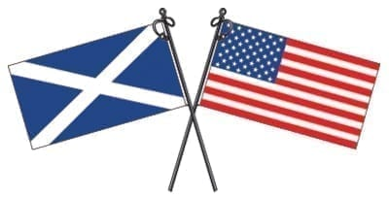
Fresno Scottish Society
P.O. Box 5699, Fresno, California 93755-5699
www.fresnoscottishsociety.com
Membership Application
Name |  |  | Spouse/Partner
Address |  |  | City & Zip
E-mail |  |  | Phone (c/h/w)

Membership Dues |  | Badges & Ladders [Optional]
 | $20.00 Individual |  | Society Name Badge |  | @ $10.00 = | $
 | $30.00 Family [Spouse/Partner & Children Under 18] |  | Badge Ladders |  | @ $5.00 = | $

Annual Membership dues are payable on or before January 1st of each year. Members in arrears shall stand as suspended as of March 31st of that year, and their membership shall be cancelled by the Board of Governors at its next regular meeting.

We recommend not sending cash by mail. If paying by check, make it payable to the Fresno Scottish Society and mail with this application to the above address. If by credit card or PayPal, please do so on the website and email the application to fresnoscottishsociety@yahoo.com.

Payment Form [Check One] |  | Check | Check Number |  | Date
 |  | Cash
 |  | Credit Card
 |  | PayPal

Thank you for joining the Fresno Scottish Society!

Ceud Mile Failte! Air Son Gradh Na h-Albann
(100,000 Welcomes) (For the Love of Scotland)

For Board Use:
Application Received: ______________________________

